**Chapter # 06 (Trigonometric Function)**

**6.3 Properties of the Trigonometric Functions:**

**Objectives:** 1 Determine the Domain and the Range of the Trigonometric Functions

2 Determine the Period of the Trigonometric Functions

3 Determine the Signs of the Trigonometric Functions in a Given Quadrant

4 Find the Values of the Trigonometric Functions Using Fundamental Identities

5 Find the Exact Values of the Trigonometric Functions of an Angle Given One of the

Functions and the Quadrant of the Angle

6 Use Even–Odd Properties to Find the Exact Values of the Trigonometric Functions

**Determine the Domain and the Range of the trigonometric Functions:** Let $θ$ be an angle in standard position, and let $P=(x, y)$ be the point on the unit circle that corresponds to $θ$. Then, by the definition-

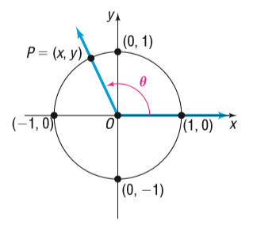

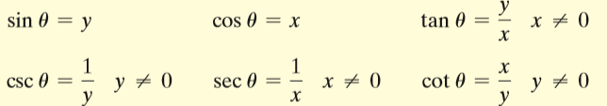

**Domain sine and cosine function:** For $\sin{θ}$ and $\cos{θ}$, there is no concern about dividing by 0, so $θ$ can be any angle. Therefore the domain of the sine function is the set of all real numbers. The domain of the cosine function is the set of all real numbers.

**Domain tangent and secant function:** The domain of the tangent function is the set of all real numbers, except odd integer multiples of $\frac{π}{2} \left({90}^{0}\right)$. The domain of the secant function is the set of all real numbers, except odd integer multiples of $\frac{π}{2} \left({90}^{0}\right)$.

**Domain cotangent and cosecant function:** The domain of the cotangent function is the set of all real numbers, except integer multiples of $π ({180}^{0})$. The domain of the cosecant function is the set of all real numbers, except integer multiples of $π ({180}^{0})$.

**Range of six trigonometric functions:** Using above figure, $P=(x, y)$ is the point on the unit circle that corresponds to the angle $θ$. It follows that $-1≤x≤1$ and $-1≤y≤1$. Since $\sin{θ=y}$ and $\cos{θ=x}$, we have $-1≤\sin{θ ≤1 and-1 ≤\cos{θ ≤1}}$

$∴$ The range of both the sine function and the cosine function consists of all real numbers between -1 and 1, inclusive i.e. $\left|\sin{θ}\right|≤1$ and $\left|\cos{θ}\right|≤1$.

If $θ$ is not an integer multiple of $π ({180}^{0})$, then $\csc{θ}= \frac{1}{y}$. Since $y=\sin{θ}$ and $\left|y\right|=\left|\sin{θ}\right|≤1$, it follows that $\left|\csc{θ}\right|=\frac{1}{\left|\sin{θ}\right|}= \frac{1}{\left|y\right|} ≥1 \left(\frac{1}{y} ≤-1 or \frac{1}{y} ≥1\right)$. That is,

$\csc{θ ≤-1 or\csc{θ ≥1}}$

Similarly, $\sec{θ ≤-1 or\sec{θ ≥1}}$

and $-∞<\tan{θ <∞, -∞<\cot{θ <∞}}$.

**Determine the Period of the trigonometric Functions:**

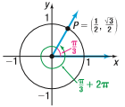 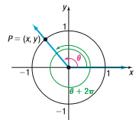

**Figure-a** **Figure-b**

$\sin\left(\frac{π}{3}+2π\right)=\sin{\frac{π}{3}}$ $\sin\left(θ+2πk\right)=\sin{θ}$

$\cos\left(\frac{π}{3}+2π\right)=\cos{\frac{π}{3}}$ $\cos\left(θ+2πk\right)=\cos{θ}$

This **figure-a** shows that for an angle of $\frac{π}{3}$ radians the corresponding point P on the unit circle is $\left(\frac{1}{2}, \frac{\sqrt{3}}{2}\right)$. Notice that, for an angle of $\left(\frac{π}{3}+2π\right)$ radians, the corresponding point P on the unit circle is also $\left(\frac{1}{2}, \frac{\sqrt{3}}{2}\right)$. Then,

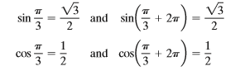

This example illustrates a more general situation. For a given angle $θ$, measured in radians, suppose that we know the corresponding point $P=(x, y)$ on the unit circle. Now add $2π$ to $θ$. The point on the unit circle corresponding to $θ+2π$ is identical to the point P on the unit circle corresponding to $θ$. In **figure-b**, the values of the trigonometric functions of $θ+2π$ are equal to the values of the corresponding trigonometric functions of $θ$. If we add (or subtract) integer multiples of $2π$ to $θ$, the values of the sine and cosine function remain unchanged. That is, for all $θ$:



**Definition:** A function *f* is called periodic if there is a positive number *p* such that, whenever $θ$ is in the domain of *f*, so is $θ+p$, and

$f\left(θ+p\right)=f(θ)$

If there is a smallest such number *p*, this smallest value is called the (fundamental) period of *f*.

**Periodic Properties: $\sin\left(θ+2π\right)=\sin{θ, }\cos\left(θ+2π\right)=\cos{θ, \tan\left(θ+π\right)=\tan{θ} }$**

$\csc\left(θ+2π\right)=\csc{θ, }\sec\left(θ+2π\right)=\sec{θ, \cot\left(θ+π\right)=\cot{θ} }$

**Example1:** Find the exact value of: **(a) $\sin{\frac{17π}{4}}$** , **(b) $\cos{5π}$** , **(c) $\tan{\frac{5π}{4}}$**

**Solution:** **(a)** Since the period of the sine function is $2π$, each full revolution can be ignored leaving the angle $\frac{π}{4}$. Then,

$\sin{\frac{17π}{4}=\sin\left(4π+\frac{π}{4}\right)=\sin\left(\frac{π}{4}\right)}= \frac{1}{\sqrt{2}}$ Ans.

**(b)** Since the period of the cosine function is $2π$, each full revolution can be ignored leaving the angle $π$. Then,

$\cos\left(5π\right)=\cos\left(4π+ π\right)=\cos{π= -1}$ Ans.

**(c)** Since the period of the tangent function is $π$, each full revolution can be ignored leaving the angle $\frac{π}{4}$. Then,

$\tan{\frac{5π}{4}=\tan\left(π+\frac{π}{4}\right)=\tan{\frac{π}{4}=1}}$ Ans.

**Determine the signs of the trigonometric Functions in a Given Quadrant:**

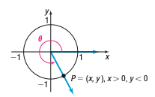

Let $P=(x, y)$ be the point on the unit circle that corresponds to the angle $θ$. If we know in which quadrant the point P lies, then we can determine the signs of the trigonometric functions of $θ$. For example, $P=(x, y)$ lies in quadrant IV, as shown in above figure, then we know that $x>0 and y<0$. Consequently,

$\sin{θ=y <0, \cos{θ=x >0, \tan{θ= \frac{y}{x} <0}}}$

$\csc{θ= \frac{1}{y} <0, \sec{θ= \frac{1}{x} >0, \cot{θ= \frac{x}{y} <0}}}$

That is,

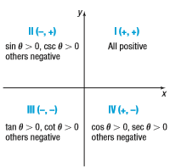

Signs of the trigonometric functions

**Find the values of the trigonometric Functions Using Fundamental identities:** If $P=(x, y)$ is the point on the unit circle corresponding to $θ$, then

$\sin{θ=y, \cos{θ=x, \tan{θ= \frac{y}{x} if x≠0}}}$

$\csc{θ=\frac{1}{y} if y≠0, \sec{θ=\frac{1}{x} if x≠0, \cot{θ=\frac{x}{y} if y≠0}} }$

**Based on these definitions, we have the reciprocal identities:**

**Reciprocal identities:**

$\csc{θ= \frac{1}{\sin{θ}}, \sec{θ= \frac{1}{\cos{θ}}, \cot{θ= \frac{1}{\tan{θ}}} }}$

**Quotient identities:**

$\tan{θ=\frac{\sin{θ}}{\cos{θ}} and \cot{θ= \frac{\cos{θ}}{\sin{θ}}}}$

**Example3:** Given $\sin{θ=\frac{\sqrt{5}}{5} and \cos{θ= \frac{2\sqrt{5}}{5}}}$, find the exact values of the four remaining trigonometric functions of $θ$ using identities.

**Solution: $\tan{θ= \frac{\sin{θ}}{\cos{θ}}= \frac{\frac{\sqrt{5}}{5}}{\frac{2\sqrt{5}}{5}}= \frac{\sqrt{5}}{5}×\frac{5}{2\sqrt{5}}= \frac{1}{2}}$**

$\csc{θ= \frac{1}{\sin{θ}}= \frac{1}{\frac{\sqrt{5}}{5}}= \sqrt{5}}$

$\sec{θ= \frac{1}{\cos{θ}}= \frac{1}{\frac{2\sqrt{5}}{5}}= \frac{\sqrt{5}}{2}}$

$\cot{θ= \frac{1}{\tan{θ}}= \frac{1}{\frac{1}{2}}=2}$ Ans.

**Fundamental identities:**

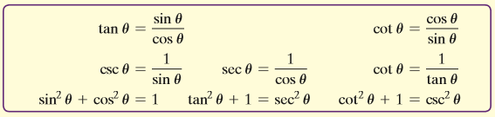

**Example:** Given that $\sin{θ= \frac{1}{3}}$ and $\cos{θ<0}$, find the exact value of each of the remaining five trigonometric functions.

**Solution:**

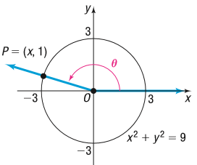

Suppose that $P=(x, y)$ is the point on a circle that corresponds to $θ$. Since $\sin{θ=\frac{1}{3}}>0$ and $\cos{θ<0}$, the point $P=(x, y)$ is in quadrant II. Because, $\sin{θ=\frac{1}{3}=\frac{y}{r}}$, we let *y* = 1 and *r* = 3. The point $P=\left(x, y\right)=(x, 1)$ that corresponds to $θ$ lies on the circle of radius 3 centered at the origin: $x^{2}+y^{2}=9$.

To find *x*, we use the fact that $x^{2}+y^{2}=9$, *y* = 1, and *P* is in quadrant II, so $x<0$.

$x^{2}+y^{2}=9 ⇒ x^{2}+1=9 ⇒x^{2}=8 ⇒x=-2\sqrt{2}$

Since, $x=-2\sqrt{2}, y=1 and r=3$

$∴\cos{θ=\frac{x}{r}= \frac{-2\sqrt{2}}{3}, \sec{θ= \frac{r}{x}= -\frac{3}{2\sqrt{2}}, \tan{θ= \frac{y}{x}= -\frac{1}{2\sqrt{2}}}}}$

$csc=\frac{y}{r}= \frac{1}{3}, \cot{θ= \frac{x}{y}= \frac{-2\sqrt{2}}{1}= -2\sqrt{2}}$ Ans.

**Using Identities (Alternative Method):** Given $\sin{θ= \frac{1}{3}}$ and $\cos{θ<0}$

Now, $\sin^{2}θ+\cos^{2}θ=1⇒\cos^{2}θ=1-\sin^{2}θ ⇒\cos{θ=-\sqrt{1-\frac{1}{9}} ∴\cos{θ= -\frac{2\sqrt{2}}{3}}}$

$$\tan{θ= \frac{\sin{θ}}{\cos{θ}}= -\frac{1}{2\sqrt{2}}}, \cot{θ= \frac{1}{\tan{θ}}= -2\sqrt{2}, \csc{θ=\frac{1}{\sin{θ}}= \frac{1}{3},\sec{θ= -\frac{3}{2\sqrt{2}}}}}$$

**Finding the Values of the Trigonometric Functions of $θ$ when the value of One Function is Known and the Quadrant of $θ$ is Known:** Given the value of one trigonometric function and the quadrant in which $θ$ lies, the exact value of each of the remaining five trigonometric functions can be found in either of two ways.

**Option 1(Using a Circle of Radius *r*):**

**Step 1:** Draw a circle centered at the origin showing the location of the angle $θ$ and the point $P=(x, y)$ that corresponds to $θ$. The radius of the circle that contains $P=(x, y)$ is $r=\sqrt{x^{2}+y^{2}}$.

**Step 2:** Assign a value to two of the three variables *x*, *y*, *r* based on the value of the given trigonometric function and the location of *P*.

**Step 3:** Use the fact that *P* lies on the circle $x^{2}+y^{2}=r^{2}$ to find the value of the missing variable.

**Step 4:** Apply the theorem to find the values of the remaining trigonometric functions.

**Option 2(Using identities):**

Use appropriately selected identities to find the value of each remaining trigonometric function.

**Use Even–Odd Properties to Find the exact values of the trigonometric Functions:** We will now show that the trigonometric functions sine, tangent, cotangent, and cosecant are odd functions and the functions cosine and secant are even functions.

**Even–Odd Properties:**

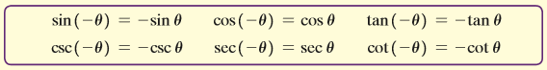

**Home Work: Exercise 6.3: Problem No. 11 - 96**

**Exercise 6.3:**

**Question no. 11- 26 are same:**

**Question 23:** Use the fact that the trigonometric functions are periodic to find the exact value of following expression: $\cot{\frac{17π}{4}}$

**Solution:** Since the period of the cotangent function is $π$, each full revolution can be ignored leaving the angle $\frac{π}{4}$. Then,

$\cot{\frac{17π}{4}=\cot\left(4π+\frac{π}{4}\right)=\cot{\frac{π}{4}=1}}$ Ans.

**Question 25:** Use the fact that the trigonometric functions are periodic to find the exact value of following expression: $\sec{\frac{25π}{6}}$

**Solution:** Since the period of the secant function is $2π$, each full revolution can be ignored leaving the angle $\frac{π}{6}$. Then,

$\sec{\frac{25π}{6}=\sec\left(4π+\frac{π}{6}\right)=\sec{\frac{π}{6}= \frac{2}{\sqrt{3}}}}$ Ans.

**Question no. 27- 34 are same:**

**Question no. 35- 42 are same:**

**Question 40:** Find the exact value of each of the four remaining trigonometric functions, where $\sin{θ=\frac{1}{2}}, \cos{θ=\frac{\sqrt{3}}{2}}$.

**Solution: $\tan{θ= \frac{\sin{θ}}{\cos{θ}}= \frac{\frac{1}{2}}{\frac{\sqrt{3}}{2}}= \frac{1}{2}×\frac{2}{\sqrt{3}}= \frac{1}{\sqrt{3}}}$**

$\csc{θ= \frac{1}{\sin{θ}}= \frac{1}{\frac{1}{2}}=2}$

$\sec{θ= \frac{1}{\cos{θ}}= \frac{1}{\frac{\sqrt{3}}{2}}= \frac{2}{\sqrt{3}}}$

$\cot{θ= \frac{1}{\tan{θ}}= \frac{1}{\frac{1}{\sqrt{3}}}=\sqrt{3}}$ Ans.

**Question no. 43- 58 are same:**

**Question 48:** Find the exact value of each of the remaining trigonometric functions of $θ$, where $\sin{θ=\frac{5}{13}, {90}^{0}<}θ<{180}^{0}$.

**Solution:**

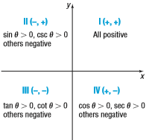

Given, $\sin{θ=\frac{5}{13}, {90}^{0}<}θ<{180}^{0}$ i.e, $θ$ is in second(II) quadrant.

Now, $\sin^{2}θ+\cos^{2}θ=1 ⇒ \frac{25}{169}+ \cos^{2}θ=1 ⇒ \cos^{2}θ=\frac{144}{169} ∴\cos{θ= -\frac{12}{13}}$

$∴ sec{θ= \frac{1}{\cos{θ}}=-\frac{1}{\frac{12}{13}}=-\frac{13}{12}}, \csc{θ= \frac{1}{\sin{θ}}= \frac{1}{\frac{5}{13}}= \frac{13}{5}}$

and, $\tan{θ= \frac{\sin{θ}}{\cos{θ}}= \frac{\frac{5}{13}}{-\frac{12}{13}}=-\frac{5}{12}, \cot{θ= \frac{1}{\tan{θ}}= \frac{1}{-\frac{5}{12}}=-\frac{12}{5}}}$ Ans.

**Question no. 59- 76 are same:**

**Question 66:** Use the even–odd properties to find the exact value of the following expression: $\sin{(-{90}^{0})}$.

**Solution: $\sin\left(-{90}^{0}\right)= -\sin\left({90}^{0}\right)=-1$** Ans.

**Question72:** Use the even–odd properties to find the exact value of the following expression: $\tan{(-π)}$.

**Solution: $\tan\left(-π\right)= -\tan{π=0}$** Ans.

**Question no. 77- 96 are same:**

**Question 84:** Use properties of the trigonometric functions to find the exact value of the following expression: $\cos\left({400}^{0}\right)\sec\left({40}^{0}\right)$.

**Solution: $\cos\left({400}^{0}\right)\sec\left({40}^{0}\right)= \cos\left({360}^{0}+{40}^{0}\right)\sec\left({40}^{0}\right)=\cos\left({40}^{0}\right). \frac{1}{\cos\left({40}^{0}\right)}=1$** Ans.

**Question 91:** If $\tan{θ=3}$, find the value of: $\tan{θ+\tan\left(θ+π\right)+\tan{(θ+2π)}}$

**Solution:** Given, $\tan{θ=3}$

$∴ \tan{θ+\tan\left(θ+π\right)+\tan{(θ+2π)}}=\tan{θ+\tan{θ+\tan{θ=3+3+3=9}}}$ Ans.